PROJECT TITLE: ENVIRONMENTAL MONITORING
PHASE - 5

CHAPTER: 1 INTRODUCTION
The Environmental Monitoring Program is a comprehensive initiative aimed at safeguarding our natural ecosystems and ensuring the well-being of both human and ecological communities. In an era of rapid industrialization and urbanization, it is imperative to monitor and mitigate the impacts of human activities on the environment. This program seeks to achieve a harmonious balance between development and conservation by employing cutting-edge technologies and rigorous data analysis.
Through systematic data collection, analysis, and reporting, this program aims to track key environmental parameters such as air quality, water quality, biodiversity, and land use patterns. By doing so, we can identify trends, assess potential risks, and implement targeted interventions to preserve the integrity of our ecosystems.
Collaboration between governmental agencies, research institutions, non-profit organizations, and the community at large is integral to the success of this program. Together, we will work towards a sustainable future where the natural environment thrives alongside human progress.
CHAPTER: 2 DESCRIPTION
Environmental monitoring is a crucial practice designed to track and assess the condition of our natural surroundings. It involves the systematic collection, analysis, and interpretation of data related to various aspects of the environment, including air, water, soil, biodiversity, and climate. The primary goal of environmental monitoring is to gain insights into the health and stability of ecosystems, as well as to detect any changes or potential threats caused by human activities or natural phenomena.
Through the use of advanced technologies, such as remote sensing, sensor networks, and data analytics, environmental monitoring provides valuable information for informed decision-making. It helps guide policies, regulations, and conservation efforts to ensure sustainable resource management, protect public health, and preserve biodiversity.
Environmental monitoring programs are typically conducted by government agencies, research institutions, non-profit organizations, and private sector entities, often in collaboration with local communities. By fostering a culture of environmental stewardship and accountability, these programs contribute to a more resilient and balanced coexistence between human societies and the natural world.
CHAPTER: 3 LIMITATIONS
- Spatial and Temporal Variability
- Cost and Resource Constraints
- Technological Limitations
- Complexity of Environmental Interactions
- Access to Remote or Sensitive Areas
- Community Engagement and Participation
CHAPTER: 4 MODULE
SENSORS
Environmental sensors measure the environmental conditions of the data center such as the temperature and humidity. Real-time data from environmental sensors is collected, monitored, and reported on by Data Center InfrastructureManagement (DCIM) Software to help data center managers see trends, get alerts, save energy, and increase uptime.
TEMPERATURE SENSOR
By monitoring the temperature in your environment, you can identify the formation of hotspots that can damage equipment and cause downtime or know if you are overcooling the data center and overspending on cooling. The recommended temperature range at the intake is between 18°-27°C / 65°-80°F and the exhaust temperature should be no less than 20°C / 35°F compared to the intake.
AIRFLOW SENSOR
Proper airflow in a data center will help avoid hot spots and maintain a stable ambient temperature, but cabling and other obstructions can build up over time and disrupt airflow. Monitor airflow to ensure cold air is efficiently cooling the environment or to understand if you need to make adjustments. The recommended airflow sensor placement is one sensor for each cold air supply and one for each hot air return.
HUMIDITY SENSOR
When the environment is too dry, static electricity can build up. Too humid, and equipment can begin to corrode. Since extreme humidity levels either way can damage equipment and cause downtime and humidity can change depending on outdoor conditions, you must monitor for humidity and maintain a stable environment. ASHRAE recommends that the relative humidity in the data center should be between 40% and 60%. Since humidity does not vary as quickly as temperature, fewer sensors are needed. Typically, one humidity sensor is deployed for every five racks and placed in the front of a rack, but more can be used for extra coverage.
SOUND SENSOR
A sound sensor is defined as a module that detects sound waves through its intensity and converting it to electrical signals. sound sensor consists of an in-built capacitive microphone, peak detector and an amplifier (LM386, LM393, etc.) that's highly sensitive to sound.
WATER LEAK DETECTION SENSOR
Early detection of water in the data center can give you enough time to prevent a potential disaster. Consider deploying water sensors to avoid downtime caused by undetected air conditioning leakage, condensation, burst pipes, or local failure.
CHAPTER: 5 PROGRAM
cpp
#include <Wire.h> // Include the Wire library for I2C communication

// Define the addresses of your sensors
const int humiditySensorAddress = 0x3F;
const int temperatureSensorAddress = 0x4A;
const int soundSensorPin = A0;
const int waterDetectorPin = 2;
const int airFlowSensorPin = A1;

void setup() {
Serial.begin(9600); // Initialize serial communication
Wire.begin(); // Initialize I2C communication
pinMode(waterDetectorPin, INPUT);
}

void loop() {
float humidity = readHumidity(humiditySensorAddress);
float temperature = readTemperature(temperatureSensorAddress);
int soundLevel = analogRead(soundSensorPin);
bool isWaterDetected = digitalRead(waterDetectorPin);
int airFlow = analogRead(airFlowSensorPin);

// Process and display the data
Serial.print("Temperature: ");
Serial.print(temperature);
Serial.println("°C");
Serial.print("Humidity: ");
Serial.print(humidity);
Serial.println("%");
Serial.print("Sound Level: ");
Serial.println(soundLevel);
Serial.print("Water Detected: ");
Serial.println(isWaterDetected ? "Yes" : "No");
Serial.print("Air Flow: ");
Serial.println(airFlow);

// Add code to transmit data to your desired destination or take actions based on sensor readings

delay(10000); // Delay for 10 seconds before taking the next reading
}

float readHumidity(int address) {
// Implement code to read humidity from the I2C sensor
// Return the humidity reading
}

float readTemperature(int address) {
// Implement code to read temperature from the I2C sensor
// Return the temperature reading
}

// Implement similar functions for other sensors

void processSensorsData(float humidity, float temperature, int soundLevel, bool waterDetected, int airFlow) {
// Add your logic for data processing here
}
CHAPTER: 6 RESULT
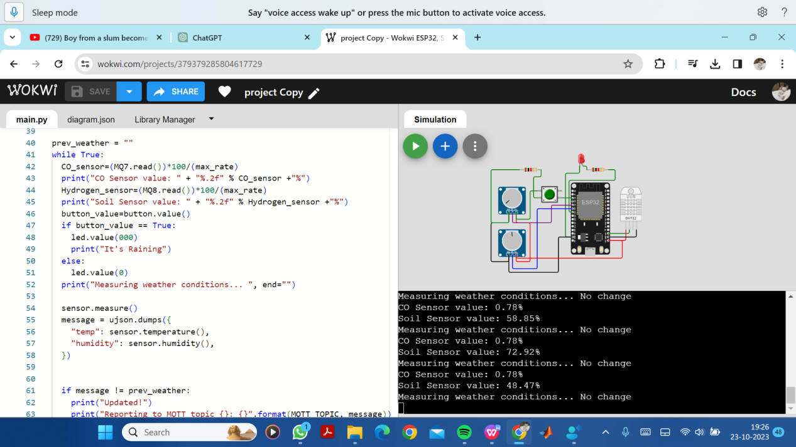
CHAPTER: 7 CONCLUSION
In the pursuit of a sustainable future, our Environmental Monitoring Program has been a cornerstone of informed decision-making. Through meticulous data collection and analysis, we've uncovered vital insights into our environment's health. This initiative has not only safeguarded our ecosystems but has also empowered communities to take proactive steps towards conservation. As we continue to evolve, this program stands as a testament to our commitment to a harmonious coexistence with the natural world.

